

Safeguarding leadership pathway

Participant workbook

  - Name:
  - Role:
  - Diocese or Cathedral:

- Introduction
The national Safeguarding Learning and Development Framework sets out the vision for making sure that all church officers develop an appropriate level of skills and knowledge in safeguarding. A ‘church officer’ is anyone appointed or elected to a post or role by or on behalf of the Church, whether they are ordained or a layperson, paid or unpaid.
We recognise the important role leaders play in creating and maintaining a safe environment for everyone, in whatever way they support the work of the Church. We are committed to helping leaders to develop and maintain the knowledge, attitude, behaviours and skills needed to safeguard and protect children, young people and vulnerable adults.

The safeguarding leadership pathway supports our vision. It is essential that we understand safeguarding as a theological essential, rooted in the nature and love of God, and demonstrated through basic commitments to valuing everyone equally.

We are committed to developing a set of National Safeguarding Standards as part of a quality-assurance framework. The quality-assurance framework will do the following.
- Ask and answer the question, ‘How well are we doing and what is the difference or outcome being achieved?’
- Analyse the answers to this question to gain learning and strengthen the Church’s understanding of, and expertise in, safeguarding.
- Use that expertise to achieve systematic change and continuous improvement in both the quality and impact of our work, and to increase our knowledge and understanding of the changing nature of
Church-based abuse.

This learning pathway has been built around the National Safeguarding Standards.
(National Safeguarding Standards | The Church of England)

The National Safeguarding Standards

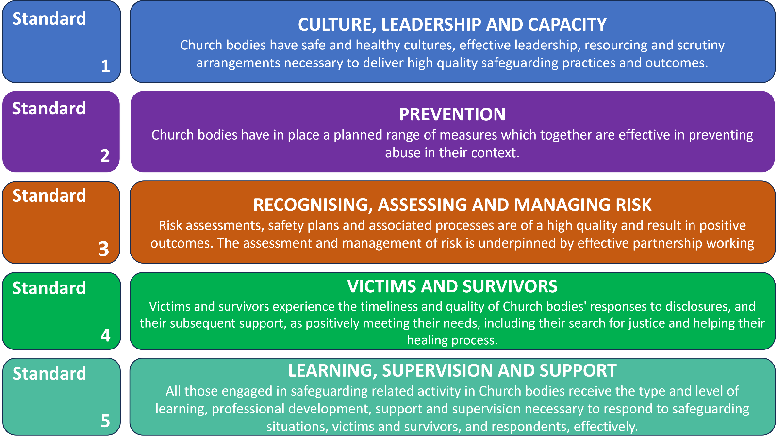

2. Learning outcomes of this pathway
This pathway is intended to be transformational. The aim is that once you have completed it, you will be in some way different from the person you were at the start. We want you to reflect deeply on your own values and beliefs and combine these with the values and beliefs that are at the heart of good safeguarding behaviour. The idea is that good safeguarding behaviour can then flow from an inner motivation, rather than it being experienced as an external process that you must (rather than want to) follow.
By the end of this pathway, you will:
  - understand how safeguarding concerns and abuse can be prevented in your church.
  - understand how healthy culture, and safe and effective leadership, shapes Christian communities that are healthy, safe and able to deliver high-quality safeguarding practices;
  - recognise when risk-assessment and risk-management processes are needed and understand when, why and how they must be used;
  - understand more about how abuse and trauma can affect people’s lives, relationships and interactions with others in a community setting, leading to better responses to victims and survivors; and
  - evaluate your learning and use it to develop an individual action plan that will improve your safeguarding practice and responses.

3. Structure of this pathway
This pathway aims to encourage a process of reflective learning involving individual tasks and groupwork. The pathway consists of two sessions, with an evaluation task after the second session. This pathway reflects our National Safeguarding Standards and creates a dedicated space to explore our culture, values, beliefs and responses to safeguarding within the Church.
- The focus of the first session is on standards one and two of our National Safeguarding Standards – culture, leadership, and capacity and prevention. Creating environments in which everyone is safe and can flourish is essential to our purpose as God’s Church. Building safer, healthier cultures is all about leading by example with our attitudes and behaviours. To create safer places effectively, we must be prepared to look at our cultures – do they support this mission and vision? How do we know that we are safe and healthy?

- The focus of the second session is on standards three and four – recognising, assessing and managing risk, and victims and survivors. In exploring how to respond effectively to safeguarding concerns, and the people involved in them, the aim is to go beyond merely considering the process. This session builds on discussions around the importance of healthy culture, leadership and capacity as the foundation of good safeguarding practices and the role that they play in preventing abuse.

- The focus of the evaluation task is on standard five – learning, supervision, and support.

The pathway is one course with two sessions. You must do some preparation work before each session, and an evaluation task after the final session. You must complete all parts of the pathway in order to receive your certificate of completion.

4. Preparing for the sessions

Before each session you must complete some preparation work. The flow chart below summarises the pathway and the preparation work.

- Participants can download their workbooks when they book the course so early booking provides more time to read and complete the preparation work for the first session. Note that it is recommended that you should download your workbook three weeks before the first session to give you time to read it and do the preparation work.
- You must return your filled-in workbook at least 4 working days before session 1.

- This is a 90-minute session made up of three exercises which focus on culture, leadership, and capacity and prevention.

- You must:
  - identify one thing that has influenced your responses, values and beliefs regarding safeguarding;
  - answer four questions which focus on risk; and
  - read the scene-setting and first scene of the case study.

- This is a 90-minute session focused on recognising, assessing and managing risk, and victims and survivors. It uses a case study which focuses on how healthy culture and leadership can prevent safeguarding concerns from escalating.

- You need to complete this six weeks after the second session to appropriately evaluate the outcomes of the course, what you have learnt from it and how you will put this into practice. You must send the evaluation to the facilitators.

Session 1
The first session focuses on the culture, leadership, and capacity and prevention standards. It will draw on the reflections made during your preparation work and your own experiences of healthy cultures. The session focuses on creating environments in which everyone is safe and can flourish, explaining that this as important to our purpose as God’s Church.

Preparing for the first session

Reflect on each of six topics shown on the culture conversation cube.

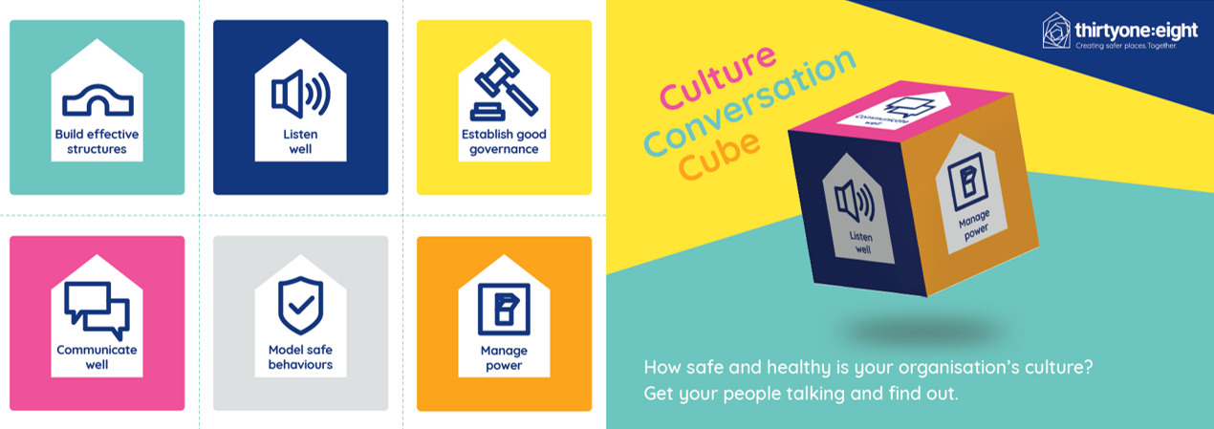

You can buy the culture conversation cube using the following link.

https://thirtyone-eight-charity.myshopify.com/products/culture-conversation-cube?pr_prod_strat=use_description&pr_rec_id=0e8478ce9&pr_rec_pid=7266692694202&pr_ref_pid=6764450742458&pr_seq=uniform

Complete a written reflection in response to each of the questions on page 9. There is no set word count or structure for these reflections, but 250 to 300 words for each question is a useful guide.

This personal reflection can also be shaped by your experience of attending the last version of the leadership pathway (if this applies) and by reading the recommended texts listed on page 30. It is not essential to read the recommended texts as not everyone will have the time to do this.

Watch and read the resources provided on the social graces. The written information is provided on page 17, and a short video presentation is available on the safeguarding training portal at https://safeguardingtraining.cofeportal.org/course/view.php?id=436

When exploring these resources, you might want to consider the following questions.
  - What factors from your own life experiences, history and characteristics could affect your beliefs, values and emotions?
- How does this affect the way you respond to others?
- How does this affect how you are seen by others?

You should email your filled-in workbook to the facilitator no later than four working days before the first session so that they can prepare for the discussion that will take place during the session. If you do not send your workbook within this time, or if your answers show that no real thought or reflection has taken place, we will ask you to complete the preparation work before inviting you to join the rest of the pathway. You must also provide evidence that you have completed the Basic Awareness and Foundation level modules.

Question 1:
Thinking about each topic on the culture conversation cube, what attitudes, behaviours and values are present within your church?
- Which are your areas of strength and which areas do you need to develop?

Build effective structures | Listen well
Establish good governance | Communicate well
Model safe behaviours | Manage power

The Code of Safer Working Practice and the Guidelines for the Professional Conduct of Clergy may help with your response to the ‘model safe behaviours’ topic.
The Code of Safer Working Practice:
Code of Safer Working Practice 02.07.2021.pdf (churchofengland.org) and also provided on page 27 of this workbook.
The Guidelines for Professional Conduct of the Clergy:
The Guidelines | The Church of England

Question 2:

If your church were a perfect example of a healthy culture, what would you see, hear, feel and experience as a member?

Question 3:

How could your church, its healthy culture and the way it is experienced help prevent safeguarding issues?

Session 2

The second session focuses on the standards of recognising, assessing and managing risk, and victims and survivors. It draws on the discussions from the first session, which focused on healthy culture, leadership and capacity, using a case study that emphasises how safeguarding concerns can be prevented from escalating.

Preparing for the second session
- Identify what has influenced your values and beliefs regarding safeguarding.
Please identify one thing that reflects what has influenced your individual connection with safeguarding and what your values and beliefs regarding safeguarding are based on. For example, this might be linked to song lyrics, nature or literature, or may depend on your own theology, religious scripture or teachings.
Please come prepared to this session. You should be able to share what has influenced you and explore how this has shaped your responses, values and beliefs regarding safeguarding.
Examples
Thomas Jefferson / Mahatma Gandhi “The true measure of any society can be found in how it treats its most vulnerable members.”
“Speak up for those who cannot speak for themselves, for the rights of all who are destitute. Speak up and judge fairly; defend the rights of the poor and needy.” (Proverbs 31:8).
Proverb: “It takes a village to raise a child.”
And you shall love the Lord your God with all your heart and with all your soul and with all your mind and with all your strength.’ The second is this: ‘You shall love your neighbour as yourself.’ There is no other commandment greater than these.” Mark 12:30-31 (English Standard Version)
- Reflect on the questions on the next page, which are designed to focus our minds on recognising, assessing, and managing risk.

- Read the case study on page 12.

Question 1

What has influenced, and therefore supports, your values and beliefs regarding safeguarding?

Question 2
On a scale of 0 to 10, where 0 is 'not at all confident’ and 10 is ‘extremely confident’, how confident are you in recognising and managing risk? What supports your score?

Question 3
What safeguarding risks exist in your own church? What are you worried about?
- What challenges have you experienced in managing a known safeguarding risk?
- How should these risks be managed or reduced? (And how are they managed or reduced?) What’s working well and what can we do to improve?
Case study

Setting
- Place: Anytown – a mid-size market town in an agricultural county. It has a population of around 15,000. There are no other towns nearby, just villages and farms. Anytown is the hub for services, shopping, education and leisure activities for a large, and mostly rural, surrounding area.
- Church: St Ethelburga’s – a mid-size church in the middle of Anytown. St Ethelburga’s has a congregation of around 80, including a small number of young people. A larger number of young people ‘hang around’ the church but don’t attend. Anytown does not have a youth club or anything similar. Several of the young ‘hangers-on’ have said they would attend a youth group if the church ran one.

Main characters
- Matthew (age 35): Matthew is the vicar. He has been at St Ethelburga’s for seven years, and it is his first post. The congregation had dwindled under the previous vicar, who had been there for 25 years until retirement, but Matthew has slowly been bringing people back since he arrived. Matthew would love to run a youth group himself but does not have time with his other commitments.
- Emma (age 33): Emma is Matthew’s wife. She runs the Sunday School and Messy Church, which have been very successful.
- Kate (age 27): Kate came back to the church following Matthew’s arrival. She runs a mother and toddler drop-in group which meets at the church on weekday mornings. Kate also helps Emma runs the Sunday School and Messy Church.
- Clive (age 67): Clive, a retired probation officer, is the parish safeguarding officer (PSO). He was appointed soon after Matthew’s arrival. Before Clive, the parish had not had a PSO for several years. Clive has worked closely with Matthew, Emma, Kate and others to get the parish’s safeguarding back ‘on track’ from where it was when he took over.
- Christopher (age 29): Christopher is an accountant. He’s very friendly and open and is currently single. He went to Bible college after school and has done some overseas mission work. He lives out of town and joined St Ethelburga’s three months ago. He gives the impression of being ‘in tune’ with the young people in the church as he has similar tastes in things like music and fashion.

Scene 1
Christopher has been going to almost every service at St Ethelburga’s since he arrived three months ago. He is popular, energetic, and seems very devout. He has been helping at tea and coffee mornings and has said he would love to join the worship band, which plays at the ‘contemporary’ service once a month (he plays guitar). He has been getting to know the young people in the church, chatting with them after the service, and knows the names of some of the other young people who hang around the church but don’t attend services. He has also got to know the wider congregation and appears to just be very friendly and engaging with everyone.

Bringing together and evaluating the learning

Traditionally, evaluation in safeguarding training – across all sectors, not just the Church – tends to focus on people reporting on their own experience of a training session they have attended. The problem with this is that it doesn’t really tell us whether training is having any effect. Do people just attend a training event, tick a box on the evaluation sheet and then carry on as before?

The evaluation that really matters is whether the learning experience has affected someone’s beliefs, values and understanding so deeply that there is a change in their behaviour. They now do things because they really want to, not because they have to. This is called ‘second order’ change and means that people do things because there is an inner motivation.

If this learning experience has been effective, you will, in some respects, be a different person from the one who started the experience.

The purpose of evaluation is to try to find out if the training has changed you.
At the beginning of the workbook, we set out the learning outcomes the programme is designed to deliver, and we have repeated them below.
By the end of this pathway, you will:
  - understand how safeguarding concerns and abuse can be prevented in your church;
  - understand how healthy culture, and safe and effective leadership, shapes Christian communities that are healthy, safe and able to deliver high-quality safeguarding practices;
  - recognise when risk-assessment and risk-management processes are needed and understand when, why and how they must be used;
  - understand more about how abuse and trauma can affect people’s lives, relationships and interactions with others in a community setting, leading to better responses to victims and survivors; and
  - evaluate your learning and use it to develop an individual action plan that will improve your safeguarding practice and responses.

If this learning programme has been successful, there will be evidence of the above behaviours, and other people will be able to see a change in your behaviour.

The evaluation task

Six weeks after the second session, complete the self-reflection (on the next page) to show how you have applied the learning from this pathway. Write an action plan which shows three to four ways that you will include what you have learnt in your safeguarding practices. Once you have completed your self-reflection and action plan, send them to the facilitator for them to review.

Leadership safeguarding pathway – self-reflection and action plan

Your name: _____________________________Location: ____________________________

Role: ____________________________________________ Date: ____________________

It is important that our leaders maintain the knowledge, attitudes and skills needed to safeguard and protect children, young people and vulnerable adults. They must also understand safeguarding as a theological essential, rooted in the nature and love of God and demonstrated in behaviour, attitudes and language that give equal value to everyone.
The overall aim is to bring about a shift in our relationship with safeguarding, so that guarding the safety of others flows from the very core of all our behaviour. Safeguarding is more than about ticking a box – it must be at the heart of everything we do.

Self-reflection
Having now completed the leadership safeguarding pathway, please reflect on what you have learnt from the sessions and how you have included this in your practice.
- What difference have you noticed in your approach to safeguarding? (For example, think about knowledge, attitude, language, importance and inclusion within your work.)

- What opportunity do you have, or could you use, to create a healthy church community?

- What would it look like for you to demonstrate behaviour that gives equal value to everyone?

Action plan
Developing a four- to six-month action plan will allow you to practise new leadership behaviour which others can see and which achieves real safeguarding outcomes. It also demonstrates that safeguarding is becoming increasingly natural to you and is at the heart of everything you do.

When developing this action plan, consider how you would use what you have learnt to:
  - reflect on how safeguarding concerns and abuse could be prevented in your church;
  - consider how healthy culture, and safe and effective leadership, shapes Christian communities that are healthy, safe and able to deliver high-quality safeguarding practices;
  - recognise when risk-assessment and risk-management processes are needed and understand when, why and how they must be used;
  - understand more about how abuse and trauma can affect people’s lives, relationships and interactions with others in a community setting, leading to better responses to victims and survivors; and
  - evaluate what you have learnt and use it to develop an individual action plan that will improve your safeguarding practice and responses.

When creating your action plan think ‘SMART’.
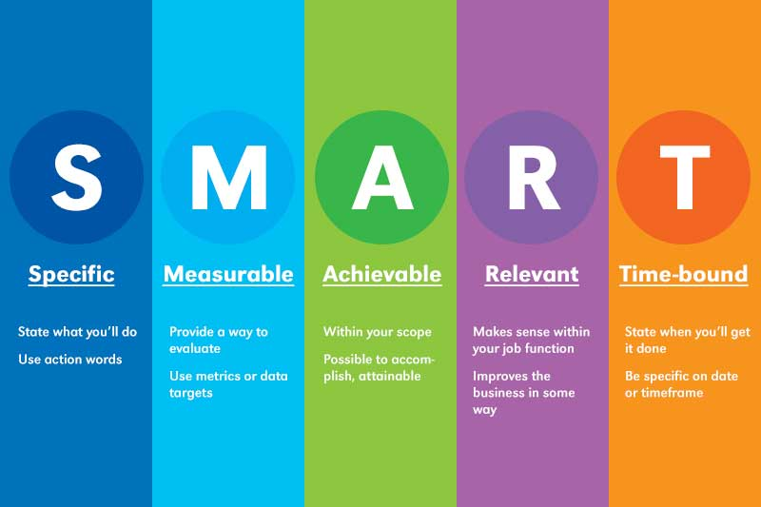

We would suggest that you develop three to four objectives for the next six to eight months.
It would also benefit your own learning and church to discuss your action plan with colleagues who might be able to support or contribute to your action plan.

Objective  What would you like to achieve? | Tasks  What do you need to do? | Criteria for success  What will it look like if you achieve your objective? | Timescale  When would you like to achieve this?
Create an environment in which safeguarding is not feared, but is spoken about openly (not just in processes and policies) | Safeguarding is discussed at Parochial Church Council (not just when reporting safeguarding concerns) | Discussions surrounding safeguarding in Parochial Church Councils are not a box-ticking exercise, but are an open dialogue in which we can explore how to create a safe space. | Six months

Further information, resources and websites

Preparing for session 1

Social graces and safeguarding
Clarification of terms
This paper introduces the concept of the social graces. This is an important concept used in modern safeguarding practice.
The term social graces is “a mnemonic that separates out different aspects of identity into separate categories” (Butler, 2017, p. 17).
The social graces
G | Gender  Geography
R | Race  Religion
A | Ability  Accent  Age  Appearance
C | Class  Culture
E | Education  Employment  Ethnicity
S | Sexuality  Sexual orientation  Spirituality  Something else

Discussions around the social graces take place in various professions, including social work, counselling and psychotherapy. So, the ‘graces’ in social graces is not referring to the Christian term ‘grace’ and its theological meaning of the unconditional and unearned love of God.

1. Introduction
The social graces propose that who we are as individuals depends on certain visible and invisible characteristics (the social graces) which, depending on the situation, can give us power and privilege. The social graces allow us to examine the aspects of identity that might affect our lives and how we behave, asking us to be aware of how our identity influences our thinking. They provide a framework for thinking about identity, which is complex and interwoven.
The social graces were originally referred to as ‘disgraces’ to highlight the fact that such inequalities were disgraceful. Over time, the ‘dis’ has been dropped and the word ‘social’ added to make sure that the aspects of identity are not just seen on an individual level, but as affecting how we are seen (and how we see others) in society and different contexts. The social graces framework was developed using the work of John Burnham and Alison Roper-Hall to make sure practitioners recognised the challenges of working with social difference, enabling them to be aware of their own preconceptions. (Burnham, J. (2012) Developments in social GRRRAAACCEEESSS: Visible-invisible and voiced-unvoiced. In I-B. Krause (Ed.) Culture and Reflexivity in Systemic Psychotherapy. Mutual Perspectives. London: Karnac.)

- What are the social graces?

The social graces represent aspects of social difference. It is not a complete list. However, it is a starting point to allow us to consider how social difference influences how we see the world.
The way the social graces are represented in the diagram below is particularly important in drawing attention to the nature of the interlinking circles. This suggests fluidity, movement and complexity. To simply list the individual social graces may result in us not paying attention to how they interact with each other.

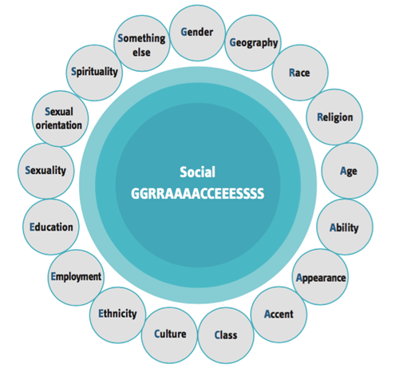

Reflection
Which social graces are you drawn to most and why?
If someone used the social graces to describe you, what do you think this description would be?

3. How do the social graces affect how we respond to a safeguarding concern?
When responding within a safeguarding context it is important that we are aware of how we are seen by others and how we see other people. All too often, survivors of abuse (across different contexts) say that they feel they are seen as a part of a group rather than as individuals. The social graces make sure we pay attention to both visible and invisible characteristics that shape our experiences of the world. The phrase, ‘There is more to me than meets the eye’ is central when thinking about the social graces, as we need to look beyond the characteristics we can see (visible) or are told about (voiced) to those that are unvoiced and invisible.
The social graces affect how we respond to safeguarding concerns. They require us to:
- look at what aspects of our identity give us privilege;
- acknowledge how we are seen by people from outside the Church and look at how this affects power, privilege and or individual responses to others; and
- reflect on how our own and other people’s visible, voiced, invisible and unvoiced social graces may affect the assumptions we and other people form, the responses we give and the decisions we make (or fail to make).

4. Visible, voiced, invisible and unvoiced social graces
Let’s think about a kaleidoscope. Images move backwards and forwards, getting larger and smaller, and blurring into each other. The same can be said for the social graces. The aspects of our own identity (and other people’s) expand, contract, collide, temporarily move forward or fade away depending on the context.
Characteristics of identity can be visible and invisible, voiced and unvoiced. Visible characteristics may be seen due to visual clues, such as sex or gender, race, culture, appearance and ability.
The aspects of social graces may vary in the way they are visible or invisible (whether they can be seen and are obvious) and voiced or unvoiced (whether they can be named or discussed) and this can change depending on the context.

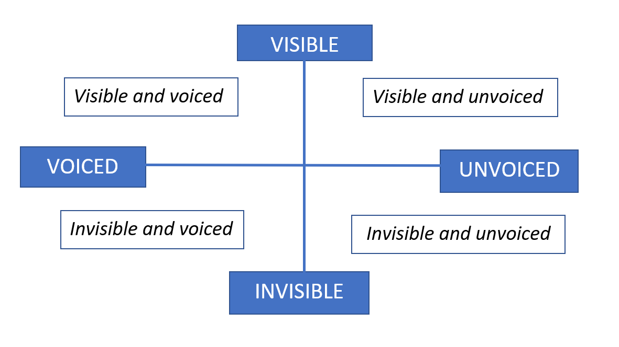

Example
A white, middle-class, professional male will be given privilege by society due to his class, gender and professional role. However, he may have invisible social graces, such as his sexuality, that remain unvoiced and, in certain circumstances, will result in disadvantage. In some situations a person’s sexuality may be an invisible-voiced social grace. However, in other social circumstances, due to under-representation and fear of disadvantage, this may be invisible-unvoiced.

The nature of social graces means there is a state of change. Like images in a kaleidoscope, the characteristics move backwards and forwards and blur into one another. In different contexts, certain aspects of a person’s identity will take a position of being voiced or unvoiced, visible or invisible. Social graces are dynamic and change depending on the context, sometimes colliding together and always connected to each other (Burnham, 2013).

Example
A female Afghan refugee with conversational English will be under-represented in a mainly white, middle-class, rural village. She might feel disadvantaged due to her culture, gender, birth country, ability and religion, all of which will be visible or voiced in social situations. However, she has a medical degree and her education is an invisible-unvoiced social grace, which would give her privilege if it were voiced.

Talking about the unvoiced and invisible social graces allows discussion about who we are and how we are influenced by things that others cannot always see.

5. Intersectionality
Intersectionality is the belief that the different parts, or sections, of our identity (race, ethnicity, sexuality, gender and so on) can never be understood in isolation. Identity will always be made up of the overlap, or intersections, of these various aspects of identity.
Intersectionality has often been in focus when aspects of the social graces overlap and lead to more than one type of marginalisation. It can be seen when social graces (such as religion, race and culture) are closely linked and hard to separate. This highlights the important understanding that social differences act alone, but are interwoven to provide either privilege or disadvantage. To understand intersectionality we must consider the power and disadvantage that aligns with different aspects of identity as they overlap.
Example
A physically disabled white man will be given privilege due to his gender and the colour of his skin, but will be discriminated against for being a wheelchair user. His age, sexuality and class will bring other privilege and disadvantage into the mix. These intersections result in a unique experience that can only be understood by people who hold all of these identities.

Reflection
What are your invisible social graces and are there times when these become voiced?
Do you feel there are any social graces missing?

6. What does this all mean?
Social graces are built by society. In some contexts, certain aspects of your identity will give you power or privilege, whereas in others they may lead to disadvantage. Social graces hold stories of pride and shame, power and privilege, and so grant positions of power.
Social graces as a concept will not take away power or privilege. But developing awareness and trying to understand what causes differences in power allows us to develop awareness of social difference and the power and privilege this gives.
This is a daisy model. It has Maya in the centre and the following social graces (the ones that she most aligns with) as the petals.
- Age
- Education
- Sexuality
- Religion
- Culture
These social graces will influence how Maya is seen by other people (and how she sees others).

Example
Maya moved from Kenya to London to study for her degree. She was privileged in Kenya due to her father’s political standing. When returning to Kenya, she is given further privilege because of her education, professional role and class. However, her sexuality is unvoiced, due to the discrimination she believes she would experience as a result of being bisexual. In contrast, in London, Maya’s sexuality is voiced, and she has privilege and power due to her role within the LGBTQ community as she uses her professional role to reduce inequality.
“I was first introduced to the social graces through a ‘line of privilege exercise’, utilised to explore how aspects of identity afforded power and privilege. I recall feeling uncomfortable as either I or a colleague stepped forward, but this exercise brought to the forefront the overriding focus of the social graces in allowing the identification of power differentials.”

The way we think about the world is tied up with the position and power we have within it, and this will change depending on the different contexts we are in and groups of people we might be involved with.

7. Presumption, bias and preconceived perceptions
Social graces and our life experiences will influence our own outlook and relationships, both professionally and socially. Social graces allow us to explore how we make sense of communication, relationships and experiences, and how these affect our understanding, decision-making and the relationships we form with others.
We need to consider how our interactions with others and life experiences shape our biases, perceptions and the presumptions we make about people.
The word ‘bias’ tends to have negative connotations. However, bias is only negative when we are not aware of our own biases and how they influence our behaviour and relationships. Exploring the social graces allows us to challenge and reflect on our own bias and, rather than try to remove it, requires us to accept how and why it is formed.

Example
“When you look at me who do you see?”
“I see all the previous social workers who have let me down, who have not supported me and want to take my children away.”
The answer to the above question, ‘When you look at me who do you see?’ will depend on the presumptions and perceptions of the person answering it. There will be instances when people ‘see’ us in a certain way because of an overriding aspect of our identity, such as employment, culture or gender. This can lead us to be grouped with (or ‘tarred with the same brush’ as) others who share that aspect of identity by some people due to their previous experiences.

What does this mean? We need to be aware not only of how we are viewed due to social graces and the related power, but also how we might view others, and this requires us to reflect on preconceived perceptions, bias and presumptions.
The nature of preconceptions can lead to people being grouped together due to similarities in their visible and voiced social graces.


Time to think
When entering a professional or social situation, who are you drawn to?
When entering a room full of people you don’t know, who are you drawn to?
Why are you drawn to these people?

Reflection
Using the daisy model and the social graces you are most drawn to, which of the social graces gives you privilege or causes disadvantage:
- in your professional role?
- in your social context?
Ask yourself the following questions.
- Have you ever been overlooked for a promotion because of your gender?
- Have you ever felt too intimidated to reveal your sexuality to colleagues?
- Has a disability ever prevented you from contributing in the workplace?
- Have you ever been rejected from a job application based only on your surname?

8. How does this affect how we respond to safeguarding concerns?
Power and privilege are given by society. What is not given by society is a person’s ability to harm others, to pose a safeguarding risk, or to be a victim or survivor of abuse.
Our responses in different contexts are affected by the power and privilege given by society. All too often, power and privilege will be granted because of someone’s position in society. This can affect our assessment of, and the decisions we make about, safeguarding situations.
Professionals are often required to reflect on the effect of social graces in their work, and how this affects the way they interact with others and respond to safeguarding concerns.

Example
Two families are in the process of being assessed due to concerns about parental alcohol misuse.
The first family is upper-middle class, living in a wealthy area. Both parents work in the legal profession and the children go to a prestigious private school. The second family lives in a deprived area. Neither parent works and they both receive Universal Credit. The children receive free school meals.

Time to think
What are the social graces that give privilege or cause disadvantage to each family?

In this example, the professional responses to the families will differ due to power and privilege. Working with the first family may be seen as disempowering for professionals, as they find their own power and privilege is reduced due to the power and privilege society gives to the family. This makes it difficult for the professionals to challenge and have a direct discussion with the family. However, the professionals working with the second family will hold power and privilege, so will find it easier to challenge the parents on their behaviours and the risk to their children.

The example above highlights how social graces can affect our ability to challenge individuals in certain circumstances. Our power and privilege will give power to and take it away from other people, depending on the context. Understanding and reflecting on our own social graces (and those of others) allows us to explore how our responses are affected. This requires us to develop a thorough understanding of the complex link between our own social graces and those of others, and to pay attention to the patterns that influence our decision-making and responses.
Reflection
Which social graces do you think give privilege to you and others?
Has there been a time when social graces have affected your confidence to challenge someone or hold them to account?
- What happened in this situation?
- What were your emotional responses?
- Did you overcome your emotional response? If so, how?
Do power and privilege affect our ability to hold people to account within the Church?
Can you think of a situation where your response to someone has been influenced by your view of their lack of power and privilege? Do you now question that response?

9. Final reflections and summary
The cornerstone to systemic practice and principles (such as the social graces) requires individuals to reflect, be curious and try to see the world from different perspectives. Within the field of safeguarding, the social graces give us the opportunity to challenge disadvantage and privilege. Consciously reflecting on how our identity and life experiences affect how we act and interact with others helps us to make the best possible judgements in safeguarding situations.
Within safeguarding, we must remember the following.
- Fast, unconscious thinking leads us to make assumptions. We must take time to pause and reflect to make sure we are aware of what might influence our assumptions.
- Exploring the social graces allows us to reflect on what shapes our attitudes, perceptions and biases, all of which will influence how we work with other people.
- The nature of the human mind and perceptions caused by society can lead people to share the same view of certain groups of people (for example, the clergy or survivors of abuse).
- Reflecting on the aspects of the social graces that give privilege allows us to be aware of these when working with others, while considering how our visible social graces can lead others to make presumptions about invisible aspects of our identity.
- Exploring the social graces requires us to check for assumptions and preconceived knowledge. Working with individuals to find out about their unique experiences of disadvantage and privilege will help us gain a greater understanding of how people are affected by their life experiences.

Further reading
- Burnham, J. (2012), Developments in social GRRRAAACCEEESSS: Visible-invisible and voiced-unvoiced. In I-B. Krause (Ed.) Culture and Reflexivity in Systemic Psychotherapy. Mutual Perspectives. London: Karnac
- Butler, C. (2017), Intersectionality and systemic therapy, Context, 151, pages 16 to 18
- Totsuka, Y. (2014), ‘Which aspects of social GGRRAAACCEEESSS grab you most? ‘The social GGRRAAACCEEESSS exercise for a supervision group to promote therapists’
self‐reflexivity. Journal of family Therapy, 36, pages 86 to 106

Preparing for session 2
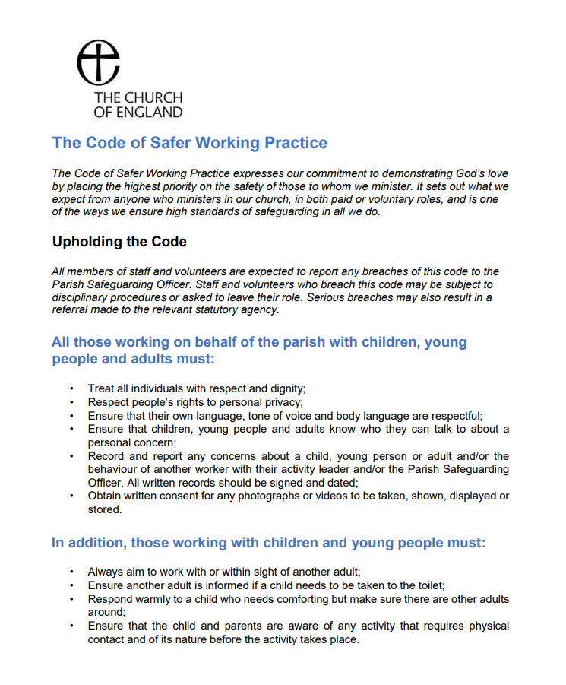

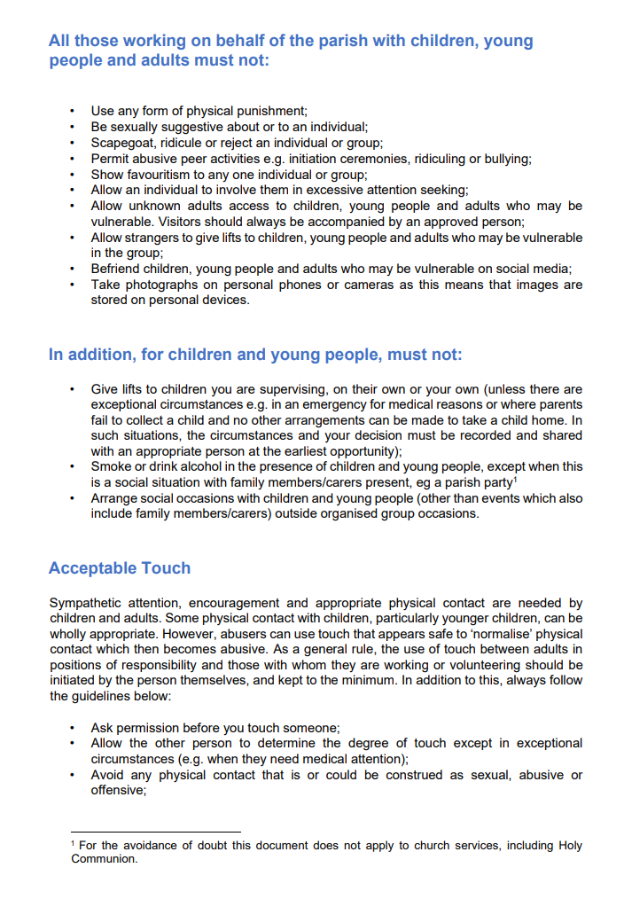
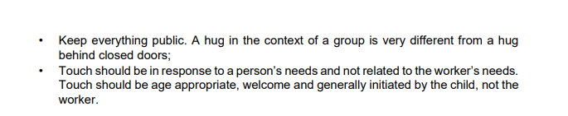
Relevant texts

Oakley & Humphries (2019), Escaping the Maze of Spiritual Abuse. Creating Healthy Christian Cultures. SPCK Publishing https://spckpublishing.co.uk/escaping-the-maze-of-spiritual-abuse
Fife, Janet and Gilo (2019), Letters to a Broken Church. Ekklesia
Harper and Wilson (2019), To Heal and Not to Hurt: A fresh approach to safeguarding in Church. Darton, Longman and Todd
Merchant (2020), Broken by Fear, Anchored in Hope: Faithfulness in an age of anxiety. SPCK Publishing https://spckpublishing.co.uk/broken-by-fear-anchored-in-hope
Frankl, Viktor (2004), Man's Search for Meaning: The classic tribute to hope from the Holocaust. Rider
Atkinson (2014), Struggling to Forgive: Moving on From Trauma. Monarch Books

Atkinson (2006), Breaking the Chains of Abuse: A Practical Guide. Lion Books

Gardiner (2021), Sex, Power, Control: Responding to Abuse in the Institutional Church. www.lutterworth.com

Honeysett (2022), Powerful Leaders: When Church Leadership Goes Wrong and How to Prevent It. www.thegoodbook.co.uk

Graystone (2021) Bleeding for Jesus. Darton, Longman and Todd
www.dartonlongmantodd.co.uk

MacFarlane (2021) Going Public: A survivor’s journey from grief to action.
Going Public a Survivor's Journey from Grief to Action by Julie Macfarlane - Paperback / softback - 9781771134750 (hymnsam.co.uk)

The Independent Inquiry into Child Sexual Abuse, Report on The Anglican Church
The Anglican Church: Safeguarding in the Church of England and the Church in Wales (iicsa.org.uk)
The National Report on Past Cases Review 2
Past Cases Review 2 - National Report.pdf (churchofengland.org)
The SCIE overview report
SCIE Final overview report of the independent diocesan safeguarding audits and additional work on improving responses to survivors of abuse.pdf (churchofengland.org)

The Church of England’s safeguarding policies
https://www.churchofengland.org/safeguarding/promoting-safer-church/policy-practice-guidance

Websites

www.nspcc.org.uk (National Society for the Prevention of Cruelty to Children)
www.womensaid.org.uk (female domestic abuse charity)
www.restoredrelationships.org (Christian domestic abuse charity)
www.mankind.org.uk (male domestic abuse charity)
www.stopitnow.org.uk (child safeguarding organisation)
www.scie.org.uk (Social Care Institute for Excellence)
www.ceop.police.uk (child exploitation and online protection command)
www.wearehourglass.org (adult safeguarding charity)
www.ageuk.org.uk (adult safeguarding charity)
www.barnardos.org.uk (child protection charity)
www.theclewerinitiative.org (modern slavery charity)
www.modernslavery.co.uk (modern slavery charity)
www.macsas.org.uk (survivor advocacy charity)
https://houseofsurvivors.org/
https://survivingchurch.org/
Helplines for further support
- Safe Spaces
Safe Spaces is for anyone who has experienced Church-related abuse, of any type, in England or Wales. Safe Spaces has a team of support advocates who are specially trained in supporting survivors of sexual violence and have received additional training in how churches respond to abuse cases, the way in which faith and Church-related settings have been used to carry out abuse, and the issues affecting people who have had, or still have, a relationship with the Church. You can contact the Safe Spaces team using the following details.
Phone: 0300 303 1056
(answerphone available outside of opening times)
Email: safespaces@firstlight.org.uk
A live chat service is also available through the Safe Spaces website – Safe Spaces England and Wales – Home - Safe Spaces England and Wales
Opening times: Monday to Friday: 9am to 9pm, Saturdays: 9am to 1pm, Sundays: 1pm to 5pm

- NSPCC – For adults concerned about a child – 0808 800 5000
- ChildLine – For children and young people – 0800 1111
- Action on Elder Abuse helpline – 0808 808 8141
- 24-hour National Domestic Violence Helpline – 0808 2000 247
- NAPAC – Support and advice for adult survivors of childhood abuse – 0808 801 0331
- Stop It Now – Preventing child sexual abuse – 0808 1000 900
- Cruse – Bereavement helpline – 0808 808 1677

