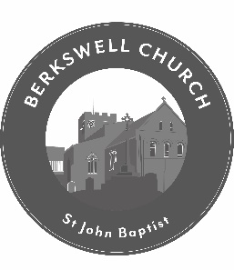
The Parish Church of St John Baptist, Berkswell
Vacancy: Part-time Assistant Parish Administrator
St John Baptist, Berkswell is an Anglican semi-rural parish church serving the village of Berkswell and part of neighbouring Balsall Common. Situated close to Coventry and Solihull, St John Baptist is a welcoming community church with a lively Junior Church and has a team of volunteers supporting the Ministry.
We are looking to recruit an individual who is highly organised, has good administrative and communication skills to assist the Parish Administrator in the day to day running of the Parish Office and a wide variety of administrative tasks that support the mission of the church.
St John Baptist is committed to safeguarding and promoting the welfare of children, young people and vulnerable adults. All post holders and volunteers are expected to share this commitment.
The successful applicant will have:
- Experience in administration or working in an office environment
- Good interpersonal and communication skills, both written and verbal
- Work well in a team as well as on their own
- A keen eye for detail and be able to follow processes effectively
- A general knowledge of IT applications including simple spreadsheets, word processing and Publisher.
The successful applicant will interact with members of the Ministry, Leadership Team and volunteers, a knowledge of church life would, therefore, be an advantage but not essential.
As a faith-based organisation and place of Christian worship, the post holder will need to be sympathetic to the Christian faith although there is not an occupational requirement for the role holder to be a committed Christian.
Hours: 6 hours per week. Working pattern to be agreed but potentially across two days.
Salary: £12.00 - £14.00 per hour, dependent on experience.
Start date: As soon as possible after appointment but no later than September.
Closing Date: Friday 28th July. Interviews will take place early to mid-August
For more information or an informal conversation please contact Janet Roberts, Parish Administrator, on 01676 529123 (weekday mornings)
For the full role description, person specification and application form please email the church parish office: office@berkswellchurch.org.uk or contact by telephone as above.
Please note that all appointments are subject to satisfactory pre-appointment checks, including references and proof of eligibility to work in the UK.

