
Keep Growing: Resources for Year 6 Transitioning
to Secondary School
  Purpose |  | People | X | Prayer |  | Place |  | Plan |  | Progress

Ten Ways to Love

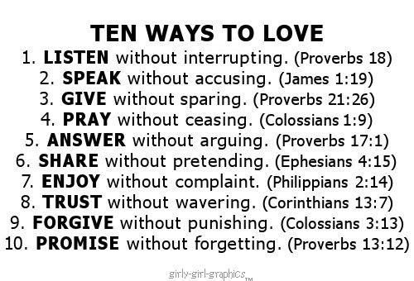
You have probably heard about how important love is lots of times. But what does it mean? The Bible says that God is love and that if we love others people will recognise us as disciples of Jesus. But how do you do it?
Look at the list on the left. Use a Bible (a book or online) to read each of the Bible verses and spend some time thinking about how you could love in this way. As you practice these different kinds of love, highlight/shade in each one.

