
Keep Growing: Resources for Year 6 Transitioning
to Secondary School
  Purpose |  | People |  | Prayer | X | Place |  | Plan |  | Progress


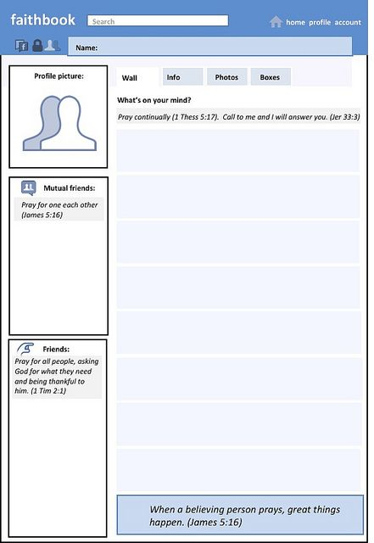
Social Prayers

Often, we worry about our friends and family. Prayer is a good way to offer those worries to God.
Remember, in prayer you can:
- Say thank you
- Intercede (pray on behalf of someone else)
- Say sorry
- Ask for help
- Celebrate God’s goodness
Use the templates to write/draw your prayers for others

