
Keep Growing: Resources for Year 6 Transitioning
to Secondary School
  Purpose |  | People |  | Prayer | X | Place |  | Plan |  | Progress


Year 6 Life Labyrinth

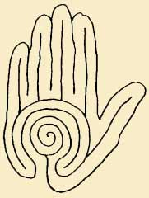






Reflection Question 5: What is God saying to me as I wait?
Reflection Question 4: Where do I see myself in the future?
Reflection Question 3: What has my journey been like so far?
Reflection Question 2: What am I looking for in life?
Reflection Question 1: Who has God made me to be?

